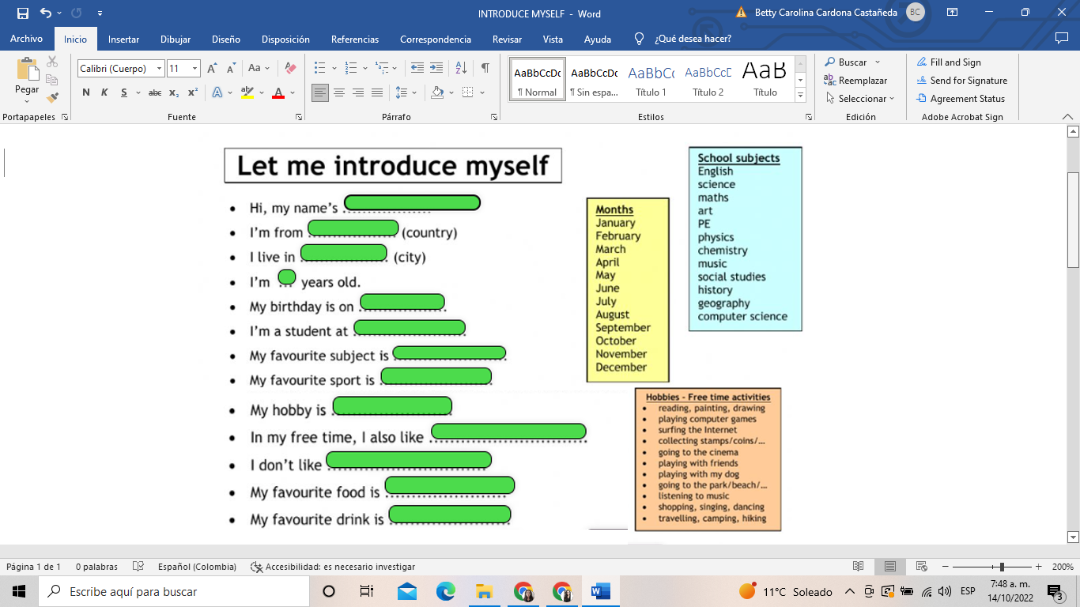­

/Lif/

One – first

Two – second

Three – third

Four – fourth

Five – fifth

Six - sixth

in March

One – first

Two – second

Three – third

Four – fourth

Five – fifth

Six - sixth

on 21st March

One – first

Two – second

Three – third

Four – fourth

Five – fifth

Six – sixth

Seven - seventh

Teen ( 13-19) 30 ty

20 ty

30 – ty

40 - ty

Two – second

Three – third

Four – fourth

Five – fifth

Six - sixth

Good evening